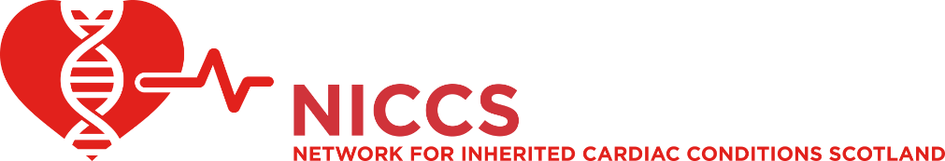

Symposium 2022
Friday 9th September 2022
The Station Hotel, Perth

10:00 – 10:25 | Registration
10:25 – 10:30 | Welcome and Introduction | Dr Caroline Coats  Dr John Dean  NICCS Lead Clinicians
10:30 – 11:00 | Covid-19 & Cardiomyopathy | Dr Kenneth Mangion, University of Glasgow
11:00 – 11:30 | Arrhythmogenic cardiomyopathy: diagnosis and risk assessment (presenting virtually, live Q&A) | Dr Alexandros Protonotarios, University College London
11:30 – 11:45 | Break
11:45 – 12:00 | A new Genomics Strategic Network for Scotland | TBC
12:00 – 12:15 | Case Based learning: Cardiomyopathy | Dr Alice Jackson, Dr Catherine McWilliam and panel
12:15– 12:45 | Workshop Session 1  A: Imaging Challenges (in-person)  B: ECG Challenges (virtual) | NB. ECG session will be face to face in Workshop 2
12:45 – 13:30 | Lunch
13:30 – 13:45 | Case based learning: Pregnancy | Dr Lorna Swan & Panel
13:45 – 14:05 | Aortopathy in Scotland – a surgeon’s perspective | Mr George Gradinariu NHS GJNH
14:05 – 14:30 | Lessons from MBRRACE-UK: Pregnancy and inherited cardiac conditions | Dr Esther Youd, University of Glasgow
14:30 – 14:45 | Break
14:45 – 15:15 | Dealing with Bereavement – what support is there for staff? | Dr Ken Donaldson, NES and NHS D&G
15:15 – 15:30 | Case based learning: Genetics | Dr Ruth McGowan and Panel
15:30 – 15:45 | New treatments and service innovations in Inherited Cardiac Conditions. | Dr Caroline Coats  Dr John Dean
15:45 – 16:15 | Workshop Session 2  A: Imaging Challenges (virtual)  B: ECG Challenges (in-person) | NB. Imaging session will be face to face in Workshop 1
16:15 | Close

