Network for Inherited Cardiac Conditions Scotland
Inherited Cardiac Conditions Resource Pack

Welcome to the Inherited Cardiac Conditions Resource Pack.
In this pack you will find links to organisations, information materials and support that is available for people living in Scotland affected by Inherited Cardiac Conditions and their families.
This resource has been developed by the Network for Inherited Cardiac Conditions Scotland (NICCS). The Network brings together a range of professionals working in healthcare and other sectors, voluntary organisations and patient representatives to support improvements in care for children and adults who have an Inherited Cardiac Condition.
Further information on the Network for Inherited Cardiac Conditions Scotland (NICCS) is available on our website www.niccs.scot.nhs.uk or you can email us at nss.niccs@nhs.scot
If you have any comments, updates or additions to this resource pack please get in touch.
Content Last Reviewed: May 2023.
Next Review Planned: May 2024

Website: www.niccs.scot.nhs.uk Email: nss.niccs@nhs.scot

CONTENTS
SUPPORT | RESOURCE | PAGE
INFORMATION  AND SUPPORT  ON INHERITED  CARDIAC  CONDITIONS | 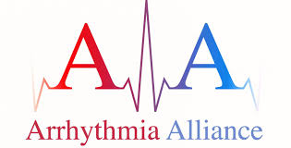 | 3
 | 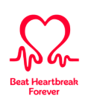  British Heart Foundation | 4
 |  | 6
 |  | 7
INFORMATION AND SUPPORT ON GENETIC  CONDITIONS |  | 9
MEDICATION AND  LONG QT SYNDROME |  | 10
INHERITED CARDIAC CONDITIONS AND LIFESTYLE RESOURCES |  | 11
SUPPORT FOR  CHILDREN AND  YOUNG PEOPLE | 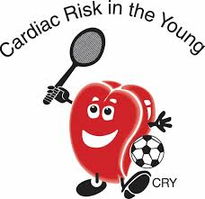 | 12
MOVING FROM CHILDRENS TO ADULT SERVICES |  | 13
 |  | 14
GET INVOLVED IN SHAPING CARDIAC HEALTH SERVICES | 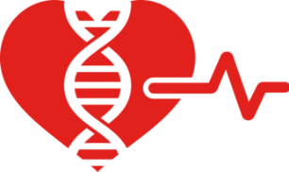 | 15
INFORMATION AND SUPPORT ON
INHERITED CARDIAC CONDITIONS

Arrhythmia Alliance (A-A) is a coalition of charities, patient groups, patients, carers, medical groups and allied professionals who work together to promote timely and effective diagnosis and treatment of arrhythmias.

If you have, or are suspected of having, cardiac arrhythmia then Arrhythmia Alliance offers you a full range of resources including:
- Patient Information booklets covering all aspects of arrhythmia care, diagnosis and treatment.
- Information fact sheets which summarise key topics related to heart rhythm disorders.
- Information checklists covering all aspects of arrhythmia care, diagnosis and treatment. These checklists help provide patients with practical information and to help them prepare for GP and hospital visits.
- Patient information video covering all aspects of arrhythmia care, diagnosis and treatment.
- Information sheets and booklets specifically for children including how the heart works, how to take a pulse and implantable devices.

The patient resources are available at: https://heartrhythmalliance.org/aa/uk/resources/arrhythmia-alliance-patient-resources

The website provides:
- links to organisations, charities, patient groups and healthcare bodies who work to improve diagnosis, care and treatment of cardiac arrhythmias.
- free education event for patients
- information on support groups.

Further information

Website: www.heartrhythmalliance.org
Telephone: 01789 867 501
Email: info@heartrhythmalliance.org
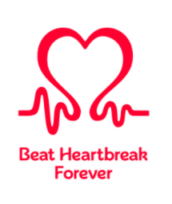
British Heart Foundation
The British Heart Foundation’s vision is a world free from the fear of heart and circulatory diseases. We raise money to research cures and treatments, so we can beat heartbreak forever.

The website has specific information and support relating to Inherited Cardiac Conditions. Information includes signs and symptoms, different conditions, genetic testing and treatment options. This can be found at:
www.bhf.org.uk/informationsupport/conditions/inherited-heart-conditions

A range of booklets are available to download or order on Inherited heart conditions:

- Familial hypercholesterolaemia
- Sudden arrhythmic death syndrome
- Inherited heart rhythm disturbances
- Hypertrophic cardiomyopathy
- Dilated cardiomyopathy
- Arrhythmogenic right ventricular cardiomyopathy

You can search the range of booklets available at: www.bhf.org.uk/informationsupport/publications

Genetic Information Service
The Genetic Information Service (GIS) can give you information and support about inherited heart and circulatory conditions. The GIS cardiac nurses can also help you understand why you, or a family member, might need to be assessed at a specialist clinic. They may be able to support your referral to a clinic too. You can speak to the specially trained GIS nurses confidentially.
Find out more at:
www.bhf.org.uk/informationsupport/support/genetic-information-service

Heart Helpline
The helplines cardiac nurses can help with lots of queries and concerns about heart and circulatory diseases, and their risk factors. Some of common queries include understanding medications and their side effects, improving diet and lifestyle and managing new and existing diagnosis.

You can contact the Heart Helpline by telephone, emailing or via the website.

Find out more at: www.bhf.org.uk/informationsupport/heart-helpline

Support Groups
Our online and local support groups provide spaces where patients and carers can share knowledge, experiences and practical help with each other. This includes support groups aimed at children and younger adults (Teen Heart – ages 13-18; One Beat ages 18 -30).

Find out more at: www.bhf.org.uk/informationsupport/support/support-groups

Support for Young People
The British Heath Foundation have information, resources and support groups to help young people with a heart condition. Explore condition factsheets, lifestyle advice and opportunities to connect with other young people.

Find out more: www.bhf.org.uk/informationsupport/support/children-and-young-peopleor further information:

Further information

Website: www.bhf.org.uk
Telephone: 0300 330 3322

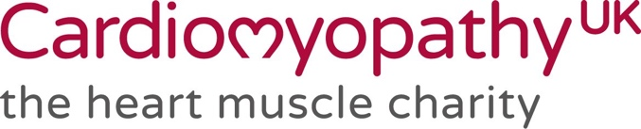

If you have, or are suspected of having, an inherited cardiomyopathy or myocarditis then Cardiomyopathy UK offers you a full range of resources. Others with inherited arrhythmias will find helpful information here too: www.cardiomyopathy.org
Support available includes:
- Cardiomyopathy Support Nurse on line and telephone advice, Mon-Fri 9am-4pm
- Peer to peer telephone support from patients just like you
- Tailored advice on how to claim PIP and other benefits
- A friendly closed FACEBOOK group where you can share your worries and concerns with folk who are already on the journey.
- Zoom and in-person Support Groups, both geographical and by type of cardiomyopathy
- A specific “teenagers and young adults” community providing support, advice and friendship.

There are also a range of articles and information available to download or order via post including:
- Each of the individual types of cardiomyopathies and myocarditis
- All about your medications
- About the heart, and heart failure
- Arrythmias
- Genetic testing, and an introduction to genetics
- Exercise advice
- Each type of device you may be offered
- Living with breathlessness
- Driving; how the rules work for you
- Travel and insurance
- Returning to work; your rights, and advice
- Impact on carers; and support for parents
- Emotional health, including resources and further information plus much more; if you’ve another concern, the chances are there is an information sheet that covers it.

Further information

Website: https://www.cardiomyopathy.org
Telephone (Office): 01494 791224
Telephone Helpline (nurses and benefits): 0800 018 1024
Email: contact@cardiomyopathy.org

Scotland’s health charity supporting people and their families across Scotland with chest, heart and stroke conditions. Chest, Heart & Stroke Scotland want to make sure life living with a chest or heart condition or after a stroke is a life lived to the full. They will fight for better health for everyone and work to make sure there is help and support in every community.
Chest Heart & Stroke Scotland are there to support you after you return home from hospital with a heart condition. Understanding your condition and learning how to manage it well at home can help you live life to the full.
Patient Information
Whether you have recently been diagnosed, have been living with a heart condition for years, or care for someone who has a heart condition, their guides will help you find out more about your condition and the support available to you.

There is a range of information available on the heart information section on the website. This includes information on common heart conditions, living with a heart condition and looking after yourself.

www.chss.org.uk/heart-information-support/

Patient and Carer Education
The website has a range of educational resources suitable for both patients and carers, which include everything from practical information about your condition to ways you can find support and resources to help you live life to the full.
Our e-learning resources will help you learn more about chest, heart and stroke conditions and empower you to self-manage your condition at home.
www.chss.org.uk/services/patient-carer-education/

Peer support groups
Meeting others and sharing experiences can make a huge difference for some people. Chest Heart & Stroke Scotland has support groups all over Scotland for people living with chest, heart and stroke conditions, and their carers.

To find out if there is a support group in your area, call the Advice Line nurses on 0808 801 0899 or email adviceline@chss.org.uk.

Chest Heart & Stroke Scotland Advice Line
A free, confidential Advice Line service, run by health professionals, provides support, information and health advice for people living with chest, heart and stroke conditions.

The Advice Line also provides support, information and advice to families, friends, carers, and health and social care professionals across Scotland.

Telephone: 0808 801 0899 (free from landlines and mobiles)
Email: adviceline@chss.org.uk
Text: NURSE to 66777 (standard rates apply)

The service is open Monday to Friday from 9:30am to 4pm.

Further information

Website: www.chss.org.uk
Telephone: 0131 225 6963

INFORMATION AND SUPPORT ON
GENETIC CONDITIONS

Genetic Alliance UK work on a variety of issues that families and individuals with genetic conditions face. They provide information, support families and influence the services needed by these patients. They also work to add patient voice into debates that matter to our community.

Genetic Alliance UK Information Pages - https://geneticalliance.org.uk/information/

Rare Resources for Scotland
A project run by Genetic Alliance UK for families in Scotland with the aim of improving access to high quality information and support for people living with rare, genetic and undiagnosed conditions in Scotland.

A collection of helpful information guides is available for families, adults and health care professionals. The website also includes a Rare Resources Directory which contains links and contact details for a variety of sources of support available in Scotland.

https://geneticalliance.org.uk/information/living-with-a-genetic-condition/rare-resources/

Further information

Website: https://geneticalliance.org.uk
Email: contactus@geneticalliance.org.uk
Telephone: 0300 124 0441

MEDICATION AND LONG QT SYNDROME

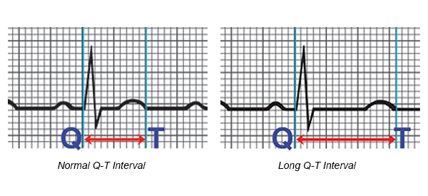

Long QT is a syndrome which can cause a disturbance in the electrical system of the heart, whilst the mechanical function of the heart can remain completely normal. It is often the result of inheriting an abnormal gene which causes an imbalance in molecules that control the electrical impulses of the heart. Long QT may result in a very fast abnormal heart rhythm (known as an arrhythmia).

There are many medications which might affect the heart rhythm in patients with Long QT Syndrome. These include some over-the-counter cough or cold remedies (decongestants) and some antibiotics. Other drugs that might affect the QT interval include some antidepressants, some treatments for fungal
infections, and drugs for heart rhythm disorders.

If you are prescribed any medicines, always check with your doctor and pharmacist that it is safe for a patient with LQTS to take these medicines. Some herbal remedies are also to be avoided (e.g. St John’s Wort). Please take care with herbal remedies and ask your doctor for specific advice.
14
A list of drugs currently known to affect long QT is available on the website www.crediblemeds.org

This list will not be exhaustive as newer drugs are becoming more available. Always inform anyone who is prescribing you medication that you have LQTS as there may be newer drugs on the market which may have not have been added to the website.

INHERITED CARDIAC CONDITIONS
AND LIFESTYLE RESOURCES

NHS Inform is Scotland’s national health information service. Their aim is to provide people in Scotland with accurate and relevant information to help them make informed decisions about their own health and the health of the people they care for.

NHS Inform has a section providing more information on inherited heart conditions including the signs and symptoms, treatment options and areas of further support. www.nhsinform.scot/illnesses-and-conditions/heart-and-blood-vessels/conditions/inherited-heart-conditions

NHS Inform also includes a section on living with a heart condition which contains a section for general advice on various aspects of living with a heart condition, like benefits, driving and going on holiday.
https://www.nhsinform.scot/illnesses-and-conditions/heart-and-blood-vessels/living-with-a-heart-condition/adjusting-to-life-with-a-heart-condition

NHS Inform also include information to support people to look after your mental and physical wellbeing with advice on stopping smoking, eating well and how to get enough exercise.
https://www.nhsinform.scot/healthy-living

SUPPORT FOR
CHILDREN AND YOUNG PEOPLE

Cardiac Risk in the Young aims to prevent young sudden cardiac deaths through awareness, screening and research, and supporting affected families.
They offer dedicated bereavement support to support families after the tragedy of a young sudden cardiac death of a person aged 35 or under.
They offer personalised help, support, and information to young people, between the ages of 12 and 35 who have been diagnosed with a life-threatening cardiac condition
Website: www.c-r-y.org.uk
Telephone: 01737 363222
Email: cry@c-r-y.org.uk

The British Heath Foundation has information, resources and support groups to help young people with a heart condition. Explore condition factsheets, lifestyle advice and opportunities to connect with other young people.

Find out more: www.bhf.org.uk/informationsupport/support/children-and-young-people

Cardiomyopathy UK have developed information
on cardiomyopathy in children and young people. There is also information for parents and carers.

Find out more:
www.cardiomyopathy.org/living-cardiomyopathy/families-and-young-people

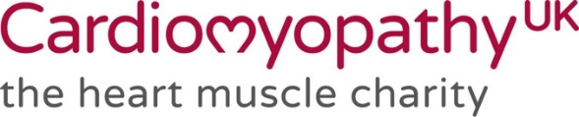

MOVING FROM CHILDRENS TO ADULT SERVICES
In healthcare, the word transition is used to describe the process of preparing, planning and moving from children’s to adult services. We understand that moving away from a team of doctors and nurses that you have been with for many years can be scary but hopefully, by getting involved in the transition process, you will feel more confident and happier about the move.

Ready Steady Go

To support you through transition, services are encouraged to use the Ready Steady Go transition programme.

Ready Steady Go is for you, if you or your child, is over 11 years old with a long-term condition.

Ready Steady Go will help you gain the knowledge and skills to manage your condition. It improves long-term outcomes and helps you gain the confidence and skills to move to adult services.

Ready Steady Go Information Leaflet: https://www.uhs.nhs.uk/Media/UHS-website-2019/Patientinformation/Childhealth/ReadySteadyGo/Transitionmovingintoadultcare-patientinformation.pdf
Ask your team about the Ready Steady Go programme or find out more at:
www.readysteadygo.net/rsg.html

The Scottish Transitions Forum’s aim is to improve the experiences of young people (14-25) who require additional support who are making the transition to young adult life.

The objectives of the Scottish Transitions Forum are to:

- Support joined up working across all services
- Continually improve knowledge, motivation and practice
- Inform and empower young people and their carers
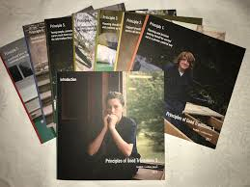
The Scottish Transition Forum’s ‘Principles of Good Transitions 3’ provides a framework to inform, structure and encourage the continual improvement of support for young people with additional needs between the ages of 14 and 25 who are making the transition to young adult life.
The Principles of Good Transitions 3 is divided into 8 parts. In addition to the introduction, each part addresses one of the seven principles of good transitions.
You can download each section individually, as PDFs, via the links below.
- Introduction
- Principle 1. Planning and decision-making should be carried out in a person-centred way
- Principle 2. Support should be co-ordinated across all services
- Principle 3. Planning should start early and continue up to age 25
- Principle 4. All young people should get the support that they need
- Principle 5. Young people, parents and carers must have access to the information they need
- Principle 6. Families and carers need support
- Principle 7. A continued focus on transitions across Scotland

Find out more at: https://scottishtransitions.org.uk/

GET INVOLVED IN SHAPING
CARDIAC HEALTH SERVICES

Patient Engagement Group

The Network for Inherited Cardiac Conditions work closely with people and families with these conditions to find out what matters most to them and to see what more we can do. One of the ways we do this is meeting with our patient group which includes people with an ICC, family members and heart charities. This group helps us to plan information events, develop patient information and patient surveys.
You can get involved in our work in different ways, such as:
- Coming along to network meetings
- Commenting on the information we develop
- Telling us about the care that you get
- Suggesting how we can better support you
- Joining our mailing list to find out what we are doing

You can tell us how you want to get involved and what support you would find helpful by scanning the QR code or visiting: https://forms.office.com/r/7cyyAC2D2C
Further information
Website: www.niccs.scot.nhs.uk
Email: nss.niccs@nhs.scot

Heart Disease Lived Experience Network

To support the implementation of the Scottish Government’s Heart Disease Action Plan, the ALLIANCE, Chest Heart & Stroke Scotland, and British Heart Foundation have set up a Heart Disease Lived Experience Network and Reference Group to directly hear about people’s individual experiences. The aim of this network is to ensure people are at the centre, that their voices, expertise, and rights drive policy and sit at the heart of design, delivery and improvement of support and services.

Further information
Website: www.alliance-scotland.org.uk/lived-experience/networks/heart-disease-network/
Email: heart@alliance-scotland.org.uk
Telephone: 0141 404 0231

