How do you get referred to the genetics team?
You or your family can be referred to the Genetics Team in a variety of ways – by your general practitioner, your cardiologist, support groups/ organisations, or you can refer yourself if a family member has been recently diagnosed. Sometimes the genetic counsellor or cardiac nurse can be the first point of contact, especially if a family member has suddenly died and the family needs someone to talk to.

Contact us:
Website: www.niccs.scot.nhs.uk
Email: nss.niccs@nhs.scot

Get Involved:
Scan the QR code or visit:
https://forms.office.com/r/7cyyAC2D2C

NHS Grampian  Clinical Genetics  Ashgrove House  Aberdeen  01224 552120 | NHS Greater Glasgow & Clyde  Genetic Service  Queen Elizabeth University Hospital  Glasgow  0141 354 9200
NHS Lothian  Genetic Service  Western General Hospital Edinburgh  0131 537 1116 | NHS Tayside  Clinical Genetics  Ninewells Hospital  Dundee  01382 632035
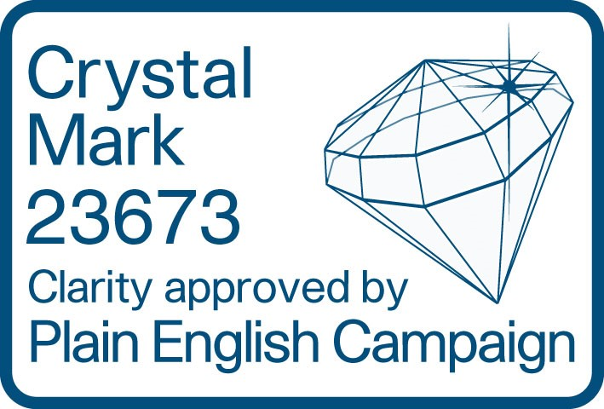
Leaflet Last Reviewed: May 2023
Next Review Planned: May 2025

How the genetics team can help you

How the genetics team can help

Finding out that you or a family member is affected by a genetic condition, such as an inherited cardiac condition, can be a very difficult time and you may have many questions that you need answered. This is when genetic counselling can help.
At the genetic clinic, you may meet with a genetics doctor (clinical geneticist) or a genetic counsellor (a health professional with specialist knowledge and experience in medical genetics). They work as part of the healthcare team, and help with finding out if there is a genetic cause to someone’s illness, and in providing information and support to families where a family member has a genetic disorder or is at risk of developing an inherited condition. They can explain the diagnosis in simple terms to help you and your family make the best possible adjustment to a new genetic diagnosis.

The genetics team will also provide you with information about what genetic testing is available, and will try to explain to you the results of any genetic tests that have already been carried out. They will also discuss what the possible implications might be for you and your family. They may be able to give you information about any implications for lifestyle, employment and insurance to help you to understand what genetic testing or the genetic diagnosis may mean for you and your family.
The genetics team also have close links with children’s health services and we often see children at the genetics clinic. We are very happy to discuss the question of genetic testing for children with you, or to talk directly to your children about the family diagnosis or genetic testing, should you so wish.

The genetics team will also talk to you about how to approach other family members such as brothers, sisters and parents, if it seems that they might be at risk too. We appreciate this can be a very upsetting time and you may prefer that discussions with relatives should be carried out at a later date. Talking with the genetics team can help explore what will be best for you or your family at this time.

What will happen at the genetic clinic?

Genetic clinic consultations last around 30 to 45 minutes with much of the time spent discussing your own particular concerns and drawing a detailed family tree – called a pedigree. The genetics doctor or counsellor will ask questions about your own medical history and about any family members affected by cardiac or rhythm problems. This helps us to see whether a condition is running through the family and, if so, how it might be inherited.

The consultation may take place in a clinic, by telephone or through a video call (“Near-Me”), depending on what is the best option at the time. Anything that you tell us about yourself is confidential and will not be shared with other members of the family without your permission. However, we may sometimes use knowledge of your family diagnosis to help arrange the right investigations and treatments for your relatives.

Genetic testing usually requires a blood sample, but sometimes (for example in children) some types of genetic testing can be done on a saliva sample. Genetic testing is not always needed – we will discuss the options during your consultation.

What happens after the genetics consultation?

You will usually receive a letter following a genetics consultation. This provides a summary of what was discussed and gives you the chance to consider the information in your own time. If any tests were arranged, including genetic tests, we will be back in touch with you again with the results and further plans.

