How do I get referred to an ICC service?

You or your family can be referred to your regional ICC service by your GP (family doctor), your cardiologist, or support groups or organisations. Or, you can refer yourself if a family member has been recently diagnosed. Sometimes a genetic counsellor or cardiac nurse can be the first point of contact, especially if a family member has suddenly died and the family needs someone to talk to.

Network for Inherited Cardiac Conditions Scotland
We are a nationally managed clinical network. The network includes doctors, nurses, counsellors and patient representatives. Our goal is to make sure that people affected by inherited cardiac conditions get high-quality care, in good time. We aim to educate healthcare professionals and the public, to raise their awareness of, and improve their knowledge about, these conditions.

Contact us:
Website: www.niccs.scot.nhs.uk
Email: nss.niccs@nhs.scot

Get Involved: Scan the QR code or visit:
https://forms.office.com/r/7cyyAC2D2C

NHS Grampian  Clinical Genetics  01224 552120 | NHS Greater Glasgow & Clyde  Genetic Service  0141 354 9200
NHS Lothian  Genetic Service  0131 537 1116 | NHS Tayside  Clinical Genetics  01382 632035

Leaflet Last Reviewed: May 2023
Next Review Planned: May 2025

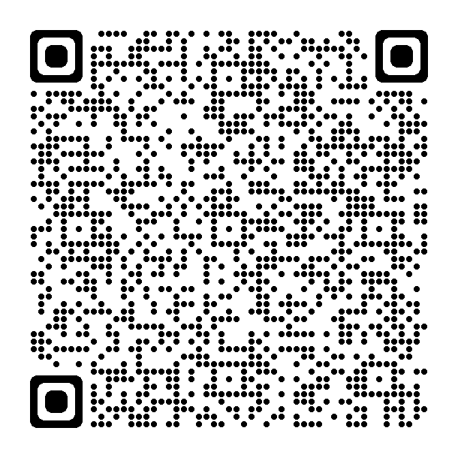

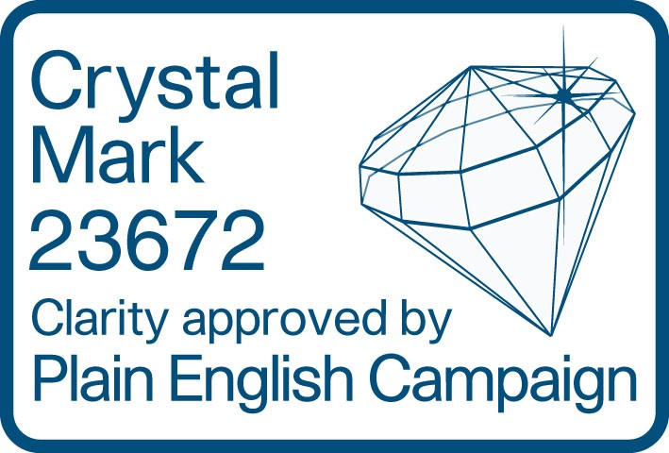

Inherited cardiac conditions

Services for patients and their families

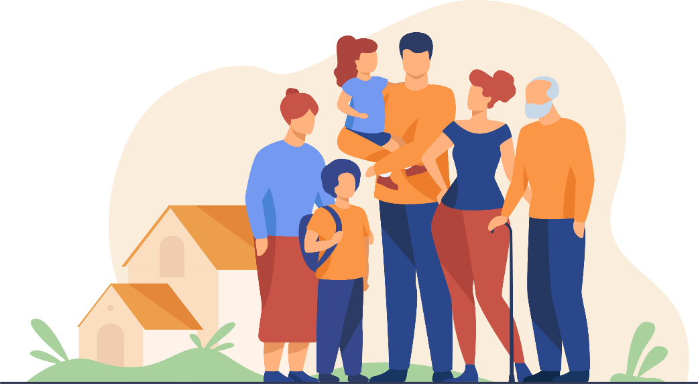

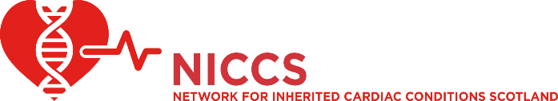
What are inherited cardiac conditions?

Inherited cardiac conditions (ICCs) are a group of different genetic conditions that mainly affect the heart or main blood vessels. There are four main groups of conditions.

1. Cardiomyopathies
These affect the heart muscle. Examples include:
- dilated cardiomyopathy;
- hypertrophic cardiomyopathy;
- arrhythmogenic cardiomyopathy; and
- restrictive cardiomyopathy.

2. Ion channel disorders or channelopathies
These affect the electrical system of the heart. Examples include:
- long QT syndrome;
- Brugada syndrome; and
- catecholaminergic polymorphic ventricular tachycardia (CPVT).

3. Neuromuscular conditions
These affect the muscles of the body and the muscle or electrical system of the heart. Examples include:
- Duchenne and Becker muscular dystrophy; and
- myotonic dystrophy.

4. Aortopathies
These conditions affect the major blood vessels. Examples include:
- Marfan syndrome.

Regional ICC services

Inherited cardiac conditions are disorders that run in families and that affect the heart muscle or heart rhythm. These conditions affect people of all ages. It is important to have specialist help for these conditions and to make sure members of your family are screened because of the complex clinical and psychosocial issues involved. In Scotland there are four regional ICC services that provide care for families. All patients with a suspected ICC should be offered a referral to their regional service.

Facilities and services

You may be diagnosed with an ICC after seeing a cardiologist or because someone else in your family has been diagnosed. Sometimes the diagnosis comes after a sudden death in the family. Most tests and investigations will be carried out at your local hospital. The ICC service may want to review the results and may recommend more tests, such as the following:

Electrocardiography and heart rhythm monitoring

Cardiac imaging (echo, cardiac CT, cardiac MRI, nuclear)

Exercise testing and pharmacological stress testing

Genetic testing and specific blood tests

Pacemaker and implantable cardioverter defibrillator (ICD) treatments

Cardiac surgery and heart transplant

Cardiac pathology

The multidisciplinary team

The ICC service is a team of healthcare professionals that provides treatment and support for a wide range of conditions. The team includes:

cardiologists (adults and children);

clinical geneticists;

specialist cardiac nurses and cardiac physiologists;

genetic counsellors;

pathologists;

cardiac rehabilitation professionals; and

clinical psychologists

