What does genetic testing involve?

During your genetic consultation, the doctor or counsellor may suggest that it would be helpful for you to have genetic testing. This usually means you need to give a blood sample, but sometimes (for example, in children) some types of genetic testing can be done on a saliva sample.

What about other members of my family?

The genetics team will also talk to you about how to approach other members of your family, such as brothers, sisters and parents, if they might be at risk too. We appreciate this can be a very upsetting time and you may prefer to discuss this with your relatives at a later date. Talking with the genetics team can help look at what will be best for you or your family at this time.

Contact us:
Website: www.niccs.scot.nhs.uk
Email: nss.niccs@nhs.scot

Get Involved:
Scan the QR code or visit:
https://forms.office.com/r/7cyyAC2D2C

NHS Grampian  Clinical Genetics  01224 552120 | NHS Greater Glasgow & Clyde  Genetic Service  0141 354 9200
NHS Lothian  Genetic Service  0131 537 1116 | NHS Tayside  Clinical Genetics  01382 632035

Leaflet Last Reviewed: May 2023
Next Review Planned: May 2025

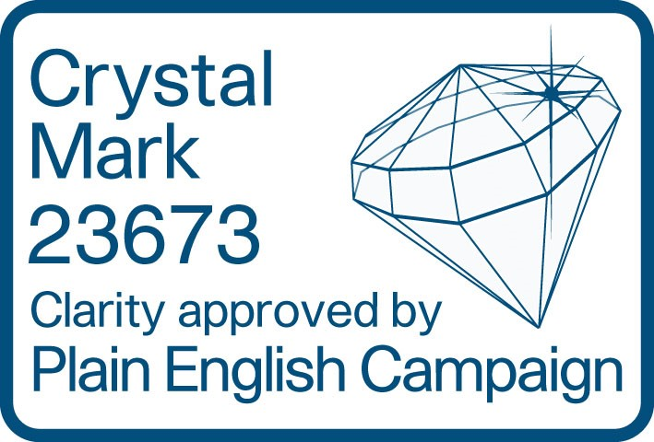

What happens after a sudden unexpected death which may be due to an inherited cardiac condition?

Sudden unexpected death

We have written this leaflet to explain what happens after a relative dies suddenly and unexpectedly, and it is suspected that this may have happened because of a heart condition that might run in the family.

Losing someone unexpectedly can be very difficult to accept at first, and may create strong emotions. Finding out more about a loved one’s death may help you to understand and come to terms with what has happened.

When someone dies suddenly and unexpectedly, there are rules which apply so that the cause of death can be investigated. This will involve a report being sent to the procurator fiscal, who is responsible for investigating all sudden or unexplained deaths in Scotland. Procurators fiscal are qualified lawyers who work for the Crown Office. There is a leaflet on their website explaining what they do. Go to: https://www.copfs.gov.uk/investigating-deaths/ our-role-in-investigating-deaths.

Post-mortem

The procurator fiscal may order a post-mortem to be carried out. This is a medical examination to find the cause of death. It is carried out by a specialist doctor called a pathologist. If the pathologist thinks the death could have happened because of a heart condition that could run in the family (an inherited cardiac condition), they will usually take a sample for genetic testing (DNA analysis). Sometimes this testing is done as part of the post-mortem to help find the cause of death, but sometimes the sample is just stored in case it is needed in the future (for example, if the cause of death can be found without genetic testing, but genetic testing may be useful to you and other relatives in the future)

My relative may have had an inherited cardiac condition – what happens next?

If the pathologist says your relative may have had an inherited cardiac condition, you should contact your GP (family doctor) to discuss what to do next.
This will probably involve being referred to the genetics service associated with your local ICCS to discuss if there is any risk to you from an inherited cardiac condition. You can find more details on our website.
Your local genetics service will be able to find out whether any genetic testing was carried out on your relative as part of the post-mortem. If no genetic testing was done, but a sample has been stored, your local genetics service can ask for this testing to be done on your behalf, even if your relative’s post-mortem took place in another city.

What happens at a genetic consultation?

Genetic clinic consultations last around 30 to 45 minutes, with much of the time spent discussing your own particular concerns and drawing a detailed family tree. The genetics doctor or counsellor will ask about your medical history and about any family members affected by cardiac or heart-rhythm problems. This helps us to see whether a condition runs in the family and, if so, how it might be inherited.

The consultation may take place in a clinic, over the phone or through a ‘Near-Me’ video call, depending on what is the best option at the time. Anything that you tell us about yourself is confidential and we will not share it with other members of the family without your permission. However, knowing about your family diagnosis will help us arrange the right investigations and treatment for your relatives.

